**Lay Marist Scotland**

|  |  |  |
| --- | --- | --- |
|  |  | **June 2019** |



# Celebration and Reflection Update

Sunday the 2nd of June was the date selected to celebrate the work of St. Marcellin Champagnat and the relationship between our Lay Marist Community in Scotland and our long standing relationship and service to Camp Marist, New Hampshire, USA.

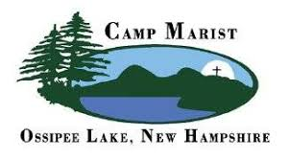

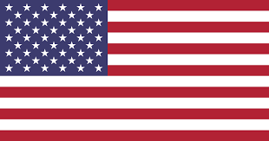 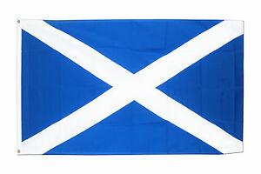 This summer, Camp Marist, USA; celebrate 70 years of providing young people from all over the world with the opportunity to experience growth, fun and community living. In parallel, Scottish staff celebrates 40 years of continued service to Camp Marist. In 1979, in the East End, Brother Charles, Brother Mungo, and Gerry Donachie, invited senior pupils to work at Camp Marist as Summer Counsellors. To date there have been over 70 Scottish staff who have worked at Camp Marist as well as supporting fundraising events at home and abroad continuing the teachings and mission of Marist Founder St. Marcellin Champagnat. Our mass was celebrated by Archbishop Tartaglia, a former pupil of St Mungo’s and Canon Tom White, who is the parish priest of St Mary’s.

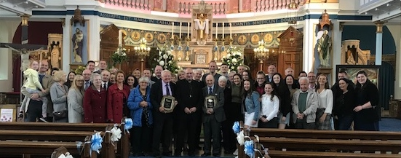

This year St Mungo’s Academy has engaged with the Marist Youth Leadership programme, which has been designed to develop leadership skills in young people in order to support fellow students and to benefit the wider community. The leadership programme continues to extend our Scottish Marist Community into the next generation.

|  |
| --- |
| Eileen O’Neil  Lay Marist Scotland  Email: [eileenoneil@live.co.uk](mailto:eileenoneil@live.co.uk)  Phone: 07721775871 |
|  |
| Eileen O’Neil  Marist Community Scotland  161 Meadowburn  Bishopbriggs  Glasgow  G64 3LH |

|  |  |  |
| --- | --- | --- |
|  | *Should you require any further information regarding the content of this Newsletter, please don’t hesitate to contact us (details below).* |  |